# 

# 

## HUMANITARIAN EXCHANGE NETWORK WITH BLOCKCHAIN SECURITY

## MINI PROJECT - I REPORT

### Submitted by

# PRAVEEN . N (21EPCI037)

# MOHAMMED RIZAD IBRAHIM . M (21EPCI030)

# RAGAVI . M (21EPCI039)

### in partial fulfillment for the award of the degree of

# MASTER OF TECHNOLOGY

**IN**

COMPUTER SCIENCE AND ENGINEERING

**SRI KRISHNA COLLEGE OF ENGINEERING AND TECHNOLOGY**

**(An Autonomous Institution, Affiliated to Anna University Chennai - 600 025)**

#### MARCH 2024



# BONAFIDE CERTIFICATE

Certified that this project report **“HUMANITARIAN EXCHANGE NETWORK WITH BLOCKCHAIN SECURITY”** is the bonafide work of **“PRAVEEN. N (21EPCI037), MOHAMMED RIZAD IBRAHIM.M (21EPCI030), RAGAVI.M (21EPCI039)”** who carried out the project work under my supervision.

##### SIGNATURE SIGNATURE

##### HEAD OF THE DEPARTMENT SUPERVISOR

Associate Professor,

Department of M. Tech CSE, Department of M. Tech CSE,

Sri Krishna College of Engg & Tech Sri Krishna College of Engg &

Tech

Coimbatore-641008 Coimbatore-641008

Submitted for the Mini Project viva-voce examination held on

INTERNAL EXAMINER EXTERNAL EXAMINER

# ACKNOWLEDGEMENT

# At this juncture, we take the opportunity to convey our sincere thanks and gratitude to the management of the college for providing all the facilities to us. We wish to convey our gratitude to our college principal, Dr. S. Sophia, for forwarding us to do our project and offering adequate duration to complete our project.

# We would like to express our grateful thanks to ________________, Professor, Head of the Department, Department of M. Tech. Computer Science and Engineering for her encouragement and valuable guidance to this project.

# We extend our gratitude to our Project Coordinator Mr. Sreeraj S, Assistant Professor, Department of M. Tech Computer Science and Engineering for his constant support and immense help at all stages of the project.

# We are grateful to our project guide Dr. S. Jothi Lakshmi, Associate Professor, Department of M. Tech. Computer Science and Engineering for his contributions of time to our project. We are also grateful for the internal and external members of the project viva voice.

# 

# ABSTRACT

# A digital platform designed to bridge surplus resources with those in need, prioritizing responsible resource management and societal impact. Employing advanced algorithms, the platform facilitates efficient matching between surplus item donations and resource requests, ensuring effective distribution. Blockchain technology is integrated to establish transparent and secure donation records, bolstering trust and deterring misuse. Robust cybersecurity measures, including fraud detection, safeguard user data and mitigate risks. The platform envisions a community-driven ecosystem, leveraging technology to foster goodwill and eliminate barriers for individuals in need. By providing a secure environment for resource exchange, the platform aims to promote sustainable practices and address pressing societal challenges. Through collaboration with verified NGOs and stakeholders, it seeks to maximize the positive impact on communities while empowering users to contribute to meaningful change. Ultimately, the platform aspires to harness the power of technology to create a more equitable and compassionate society, where surplus resources are efficiently redistributed to address the needs of vulnerable.

# TABLE OF CONTENTS

**CHAPTER NO TITLE PAGENO ABSTRACT** iv

1. **INTRODUCTION 8**
2. **LITERATURE SURVEY 9**
   1. A Comprehensive Survey on Blockchain 9

Based Decentralized Storage Networks

* 1. Implementing BlockChain Based Security 9

in EHR Using Ganache

* 1. SeVa: A Food Donation App for Smart 10

Living

2.4 Platform for Tracking Donations of Charitable 11

Foundations Based on BlockChain Technology

1. **SYSTEM ANALYSIS 12**
   1. Existing System 12
   2. Proposed System 13
2. **SYSTEM SPECIFICATION 15**

1. **PROJECT DESCRIPTION 21**

5.1 Methodology and Algorithm formulated 21

5.2 Algorithmic Matching Mechanisms 21

for Resource Allocation

5.3 Integration of Blockchain Technology 22

for Donation Records

5.4 Collaboration Framework with NGOs 23

and Stakeholders

5.5 User Privacy and Data Protection 23

Measures

5.6 Future Directions and Expansion Plans 24

|  |  |  |
| --- | --- | --- |
| **6** | **IMPLEMENTATION** | **25** |
|  | 6.1 Source Code | 25 |
|  | 6.2 Prototype Models | 27 |

|  |  |  |  |
| --- | --- | --- | --- |
| **7** | **CONCLUSION** | | **42** |
|  | 7.1 Conclusion | | 42 |
|  | 7.2 Future Work  **REFERENCES** | | 42 |
|  |  |
|  |  |
|  |  |

**LIST OF ABBREVIATIONS**

|  |  |
| --- | --- |
| **ABBREVIATION** | **EXPANSION** |
| **DRS** | **DIGITAL RESOURCE SOLUTION** |
| **RMS** | **RESOURCE MANAGEMENT SYSTEM** |
| **AMT** | **ADVANCED MATCHING TECHNOLOGY** |
| **CMS** | **COMMUNITY MANAGEMENT SYSTEM** |
| **TESS** | **TRANSPARENT EXCHANGE SUPPORT SYSTEM** |
| **CEP** | **COMMUNITY EMPOWERMENT PLATFORM** |
| **SAP** | **SOCIETAL IMPACT PLATFORM** |

**CHAPTER 1**

# INTRODUCTION

In a world marked by both abundance and scarcity, addressing societal inequalities and ensuring equitable resource distribution is imperative. This project takes on this challenge by introducing a digital platform dedicated to facilitating surplus resource donations to individuals facing scarcity. Through seamless integration of cutting-edge technologies like blockchain, and robust cybersecurity measures, the platform aims to transform how surplus resources are managed and distributed, ultimately driving positive societal change. This ensures resources are directed where most needed, enhancing efficiency and effectiveness in allocation. Furthermore, blockchain technology ensures transparent and immutable donation records, fostering trust and accountability. Donors can confidently know their contributions reach intended recipients, while recipients access resources with dignity and assurance. Central to the platform's ethos is safeguarding user data and preventing misuse. Robust cybersecurity measures, including fraud detection, protect user privacy and platform integrity. By prioritizing data security, users engage in the donation process free from concerns about vulnerabilities or breaches.

# CHAPTER 2

# LITERATURE SURVEY

**2.1 A Comprehensive Survey on Blockchain-Based Decentralized Storage Networks**

This paper provides an overview of blockchain-based storage systems in decentralized networks, emphasizing their role in enhancing trust, transparency, and data integrity. Through a comparative analysis of various storage networks and exploration of security challenges, it highlights the potential of blockchain technology in revolutionizing storage solutions. The paper offers insights into open challenges and future research directions, making it a valuable resource for understanding the intersection of blockchain and decentralized storage.

**2.2 Implementing Blockchain Based Security in EHR Using Ganache**

This paper proposes a blockchain-based electronic health record (EHR) system designed to efficiently manage patient data while ensuring privacy and security across various healthcare institutions. Developed on the Ethereum network using technologies like Ganache, Solidity, and web3.js, the system leverages smart contracts to provide robust security and privacy measures. Transactions are validated and shared across the decentralized network, ensuring data integrity and accessibility.

Key features of the system include integration with a cryptocurrency wallet (MetaMask) and a centralized privacy system, enabling authorized parties to securely access and manage patient records. By facilitating simultaneous access to data, enhancing efficiency, and fostering trust, the system aims to overcome barriers in traditional EHR systems.

The proposed solution prioritizes data security by implementing access restrictions and enabling secure record transfers. Through blockchain technology, it promotes transparency and ownership of sensitive medical data, thereby benefiting the healthcare sector.

This paper outlines the system's architecture and protocol, highlighting its potential to significantly improve the security and efficiency of healthcare systems. By addressing the limitations of traditional EHR systems, the proposed solution paves the way for transformative advancements in the healthcare industry.

**2.3 SeVa: A Food Donation App for Smart Living**

This paper introduces "SeVa," a mobile application designed to address the dual challenges of hunger and food waste by repurposing available food resources within local communities. Particularly relevant during crises like the COVID-19 pandemic, SeVa provides users with a platform to visualize and access surplus food items from restaurants, stores, and distribution centers nearing expiration. Aligned with the UN Sustainable Development Goals, the app incorporates principles from AI and HCI to create a user-friendly experience. Through IoT and ubiquitous computing, SeVa contributes to reducing hunger and food waste while making positive impacts on healthcare and the environment. The paper outlines the app's development process, including user surveys for evaluation, and identifies potential areas for future research.

**2.4 Platform for Tracking Donations of Charitable Foundations Based on Blockchain Technology**

This paper discusses the implementation of a platform for tracking donations using blockchain technology to address donor distrust regarding the allocation of donated funds. Blockchain technology offers transparency in donation processes by recording all donation-related information and transactions on a single platform. The system described in this paper aims to provide transparent accounting of operations for donors, charitable foundations, and recipients. It enables users and donors to track and monitor the route of donations, ensuring transparency in the allocation of charity funds. Through blockchain technology, the platform facilitates a transparent donation process, allowing stakeholders to monitor the flow of resources effectively.

# 

# CHAPTER 3

# SYSTEM ANALYSIS

# Existing System

# Donation Networking Platforms:

# Digital platforms akin to "OLIO" and "Too Good To Go" facilitate the connection between surplus resource holders and individuals in need, extending beyond food to encompass various goods.

# Community Resource Centers:

# Physical collection hubs, similar to community fridges, act as focal points for donating and receiving surplus goods, promoting local community sharing of various resources.

# Resource Redistributors:

# Established charitable entities specialize in redistributing surplus resources, including food from various sources like retailers, farms, and restaurants, aiding those experiencing scarcity in accessing essential items beyond food.

# 3.2 Proposed System

# Advanced Algorithms for Efficient Matching:

# Our platform employs advanced algorithms to facilitate efficient matching between surplus item donations and resource requests. This ensures that resources are distributed effectively, addressing the needs of both surplus resource holders and those in need.

# Algorithms Proposed

The Algorithm Proposed in our system includes

* + 1. Blockchain Consensus algorithm
    2. Smart contract.

# Steps proposed in Implementing the Algorithms

# 

# 1)Research and Selection:

# Choose suitable consensus algorithms for the blockchain network.

# 2)Blockchain Setup:

# Establish the blockchain network infrastructure.

# 3) Consensus Algorithm Integration:

# Implement the selected consensus algorithm.

# 4)Smart Contract Development:

# Design and develop smart contracts for donation and request processes.

# 5)Deployment and Testing:

# Deploy smart contracts onto the network and conduct thorough testing.

# 6)Integration with UI:

# Develop user interfaces for donation and request management.

# 7)Monitoring and Maintenance:

# Implement monitoring tools and procedures for ongoing system maintenance.

# Integration of Blockchain Technology:

# Blockchain technology is integrated into our platform to establish transparent and secure donation records. This enhances trust among users and stakeholders, as well as deters misuse of the system.

# Robust Cybersecurity Measures:

# Our platform incorporates robust cybersecurity measures, including fraud detection, to safeguard user data and mitigate risks. This ensures a secure environment for resource exchange, promoting trust and user confidence.

# Collaboration with Verified NGOs and Stakeholders:

# Our platform collaborates with verified NGOs and stakeholders to maximize the positive impact on communities. This ensures that resources are distributed effectively and reach those who need them most.

# CHAPTER 4

# SYSTEM SPECIFICATION

**Software Specification**:

**Frontend:**

* Framework: React
* Build Tool: Vite
* Style : Tailwind CSS

**Backend:**

* Framework: Express.js, Node.js,
* Blockchain Technology: Ethereum

**Key Features:**

**1. Advanced Matching Algorithms:**

* Utilizes React for a dynamic and responsive user interface.
* Vite is employed for fast and efficient development and bundling of frontend assets.
* Express handles the backend logic, including advanced matching algorithms for efficient resource distribution.

**2. Blockchain Integration:**

* + Implements Ethereum blockchain for transparent and secure donation records.
  + Smart contracts on Ethereum to manage and validate transactions, enhancing trust and security.

**3. Cybersecurity Measures:**

* + Utilizes secure coding practices in React and Express to mitigate potential vulnerabilities.
  + Implements robust cybersecurity measures, including proper encryption and secure API endpoints.

**4. Community-Driven Ecosystem:**

* + - Leverages React for a user-friendly and community-driven interface.
    - Vite ensures fast development cycles, fostering quick response to community needs.

**5. NGO and Stakeholder Collaboration:**

* + - Express facilitates seamless integration with backend services and databases for collaboration.
    - Ethereum smart contracts ensure transparent collaboration with verified NGOs and stakeholders.

**WORKFLOW :**

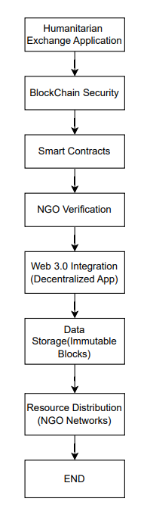

**Fig 4.1. Humanitarian Resource Exchange Application**

**WORKFLOW DESCRIPTION:**

**1. Blockchain Security:**

Prioritizing the security of the blockchain infrastructure from the start involved carefully selecting a secure blockchain platform and implementing robust network security protocols to safeguard against potential threats. Encryption techniques were employed to protect the confidentiality and integrity of data transmitted and stored within the blockchain network. Access control mechanisms were implemented to ensure that only authorized users could access sensitive information stored on the blockchain, bolstering overall security.

**2. Smart Contracts:**

Smart contracts played a pivotal role in automating and enforcing the rules governing resource exchange on the platform. These contracts acted as self-executing agreements with predefined conditions and criteria. The functionalities and parameters of the smart contracts, including resource allocation algorithms and validation criteria, were meticulously defined to streamline resource distribution efficiently.

**3. NGO Verification:**

Establishing a robust verification process for NGOs was crucial for ensuring the credibility and legitimacy of participating organizations. Leveraging blockchain technology, a transparent and auditable verification system was implemented to validate the authenticity of NGOs and their eligibility to participate in resource exchange activities. NGOs were required to submit relevant documentation and information for verification, such as registration certificates and mission statements, to undergo the rigorous verification process.

**4. Web 3.0 Integration (Decentralized Application):**

Developing a decentralized application (dApp) interface provided users with a seamless and accessible platform for engaging in resource exchange activities. Blockchain functionalities were seamlessly integrated into the dApp, enabling secure resource exchange and transparent transaction tracking. The dApp interface was meticulously designed to simplify the process of resource donation, request submission, and verification, while ensuring transparency and accountability across the platform.

**5. Data Storage (Immutable Blocks):**

Leveraging blockchain technology for immutable data storage maintained transparency and auditability of all transactions and interactions within the platform. Transactional data, user profiles, and other pertinent information were stored in immutable blocks on the blockchain network, ensuring data integrity and security. Additionally, decentralized storage solutions were employed to store larger data files associated with resource transactions, such as documents and media, further enhancing data security and accessibility.

**6. Resource Distribution (NGO Networks):**

Collaborating with verified NGOs and humanitarian organizations, a robust network for resource distribution was established. Smart contracts were instrumental in automating the allocation and distribution of resources based on predefined criteria and priorities, facilitating efficient and equitable resource distribution. NGOs were empowered to submit resource requests and receive donations through the platform, facilitating seamless resource exchange and distribution efforts.

# 

# CHAPTER 5

# PROJECT DESCRIPTION

**5.1 Methodology and Algorithm Formulated**

Methodology for the resource redistribution platform begins with comprehensive data collection and analysis, sourcing surplus resources and requests from diverse entities. This data undergoes classification based on type, quantity, quality, and location to enable efficient matching. User registration is implemented to gather pertinent information facilitating accurate resource allocation. Advanced algorithms are devised to ensure precise matching, considering factors like proximity and urgency. Blockchain technology integration establishes transparent donation records via smart contracts, enhancing trust and security. Robust cybersecurity measures, including fraud detection, safeguard user data and platform integrity. Community engagement mechanisms such as forums and feedback channels are established to solicit user input for continual improvement. Collaboration with verified NGOs enhances the platform's reach and effectiveness, validating resource requests and ensuring equitable distribution.

**5.2 Algorithmic Matching Mechanisms for Resource Allocation**

The platform employs sophisticated algorithmic matching mechanisms to facilitate the efficient allocation of surplus resources to those in need. To optimize resource allocation based on various criteria and parameters. By analyzing donor preferences, recipient needs, and resource availability, the algorithms ensure that surplus resources are allocated to the most suitable recipients. The optimization process considers factors such as geographical proximity, resource quantity, and urgency of need to prioritize allocation. Future developments aim to enhance the matching mechanisms further, incorporating feedback from users and stakeholders to optimize resource allocation processes continually.

**5.3 Integration of Blockchain Technology for Donation Records**

Blockchain technology is seamlessly integrated into the platform to provide transparency, security, and immutability to donation records. Smart contracts, programmed on the blockchain, govern the donation transactions, ensuring transparency and accountability throughout the process. Each donation transaction is recorded as a tamper-proof and immutable entry on the blockchain, providing an auditable trail of all donations made on the platform. The benefits of blockchain integration extend beyond transparency, with enhanced security measures protecting against fraudulent activities and unauthorized modifications to donation records. Challenges encountered during the integration process, such as scalability and interoperability issues, are addressed through careful planning and implementation strategies.

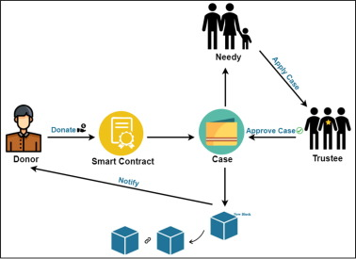

# Fig 5.3.1 Blockchain-based donations traceability framework

**5.4. Collaboration Framework with NGOs and Stakeholders**

Collaboration with NGOs and stakeholders is instrumental in maximizing the platform's positive impact on communities. A robust collaboration framework is established to foster partnerships and alliances with verified organizations and community groups. These partnerships enable the platform to leverage existing networks and resources, extending its reach and effectiveness in addressing societal challenges. Collaboration extends beyond resource distribution to encompass capacity-building, advocacy, and policy engagement, addressing systemic issues and driving sustainable change.

**5.5 User Privacy and Data Protection Measures**

User privacy and data protection are paramount considerations in the platform's design and operation. Stringent measures are implemented to safeguard user data against unauthorized access, misuse, and exploitation. Encryption protocols, access controls, and data anonymization techniques are employed to protect sensitive information and ensure user confidentiality. Additionally, privacy policies and user consent mechanisms are in place to inform users about how their data is collected, used, and shared, empowering them to make informed decisions about their privacy preferences. By prioritizing user privacy and data security, the platform fosters trust and confidence among its users, encouraging active participation and engagement in its initiatives.

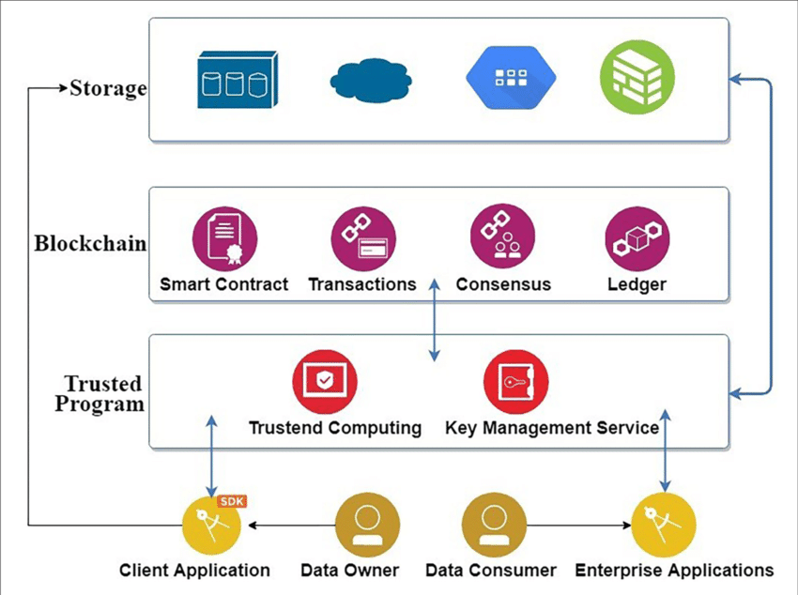

# 

# Fig 10.1 User Data Sharing Ensuring User Control and Incentives

**5.6 Future Directions and Expansion Plans**

In the realm of future development and expansion, the priority areas include expanding geographically to serve underserved communities, diversifying services to meet evolving needs, and forging partnerships with government bodies, corporations, and international organizations to access additional resources and expertise. Embracing technological advancements like blockchain integration, analytics, and IoT solutions promises to enhance operational efficiency and effectiveness. Furthermore, plans encompass capacity-building initiatives, training programs, and knowledge-sharing platforms to empower users and stakeholders, fostering a culture of innovation and collaboration. By adopting forward-thinking strategies and leveraging emerging technologies, the platform endeavors to remain a trailblazer in social innovation, driving tangible change in the lives of individuals and communities worldwide.

**CHAPTER 6**

**IMPLEMENTATION**

# 6.1 Source Code

# pragma solidity ^0.8.0;

# contract Transactions {

# uint256 public transactionCount;

# event Transfer(

# address indexed from,address indexed receiver,

# string firstname, string location,

# uint256 timestamp,

# string description, string availability,

# string transactionType);

# enum TransactionType { Donation, Request }

# struct TransferStruct {

# address sender; address receiver;

# string firstname; string location;

# uint256 timestamp;

# string description; string availability;

# TransactionType transactionType;}

# TransferStruct[] public transactions;

# function addToBlockchain(

# string memory firstname,

# string memory location,

# string memory description,

# string memory availability,

# string memory transactionType

# ) public {

# transactionCount += 1;

# TransactionType txType;

# if (keccak256(bytes(transactionType)) == keccak256(bytes("Donation"))) {

# txType = TransactionType.Donation;

# } else if (keccak256(bytes(transactionType)) == keccak256(bytes("Request"))) {

# txType = TransactionType.Request;

# } else {

# revert("Invalid transaction type");}

# transactions.push(TransferStruct({

# sender: msg.sender,

# receiver: msg.sender, // assuming the sender is also the receiver

# firstname: firstname,

# location: location,

# timestamp: block.timestamp,

# description: description,

# availability: availability,

# transactionType: txType}));

# emit Transfer(

# msg.sender,msg.sender,firstname,

# location,

# block.timestamp,

# description,

# availability,

# transactionType );}

# function getAllTransactions() public view returns (TransferStruct[] memory) {

# return transactions;

# }

# function getTransactionCount() public view returns (uint256) {

# return transactionCount; }}

# 6.2 Prototype Models

# Home

Our homepage serves as the gateway to our humanitarian exchange platform, meticulously crafted using React.js and Tailwind CSS to ensure seamless functionality and an engaging user experience. Our homepage embodies our commitment to leveraging technology for social good, providing a centralized hub where individuals, organizations, and NGOs can come together to address pressing societal challenges. With its user-friendly design, robust functionality, and emphasis on transparency and accountability, our homepage sets the stage for a transformative experience that empowers users to make a tangible difference in the lives of others.

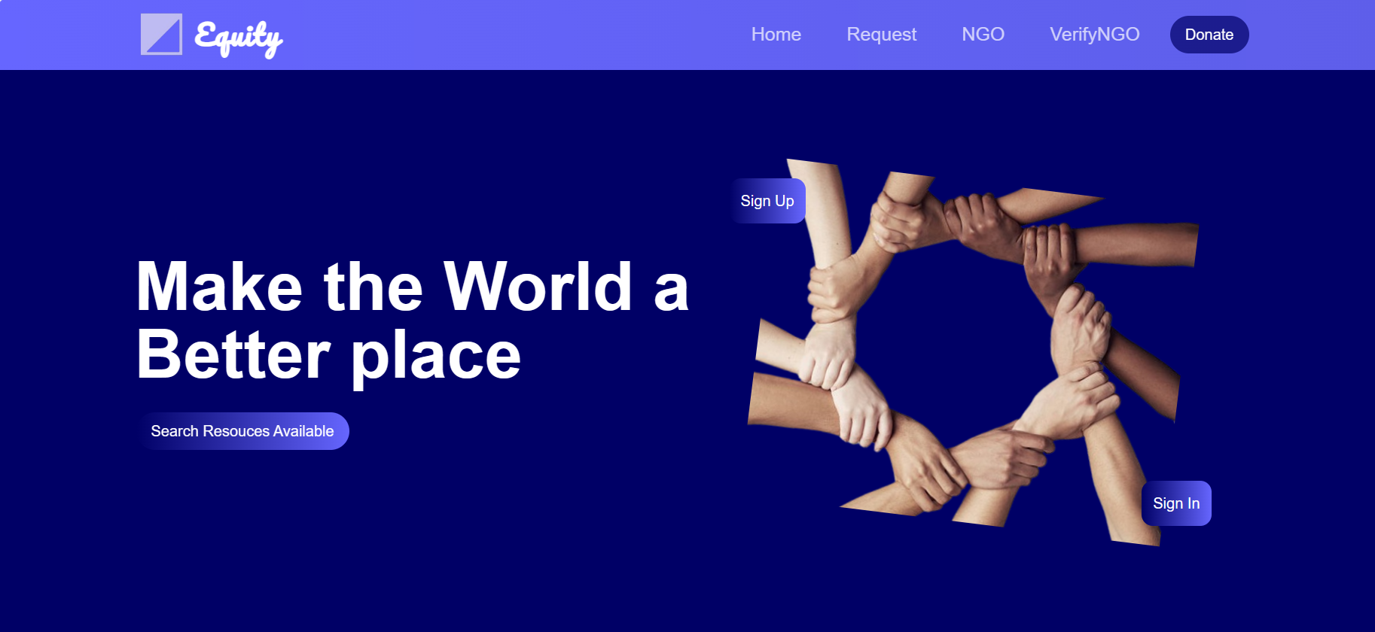

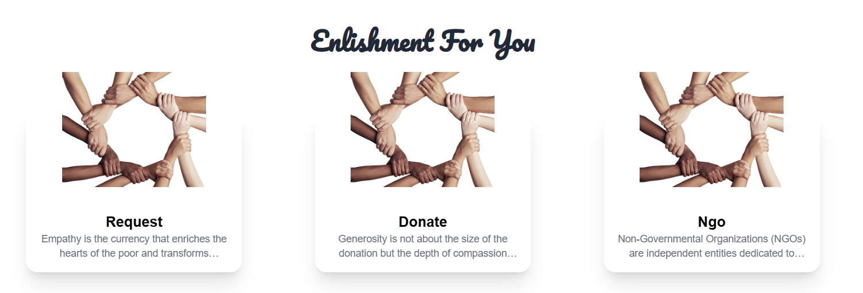

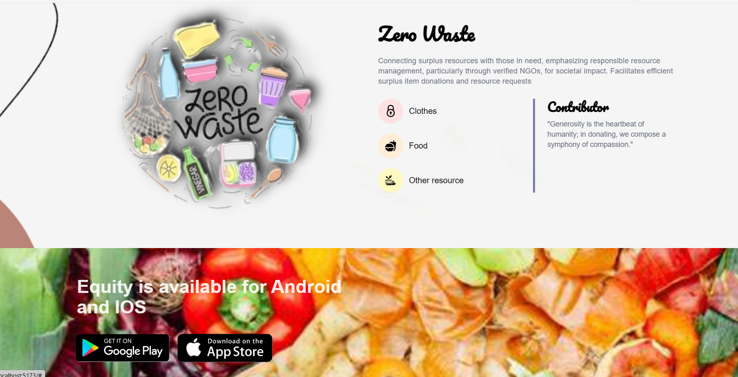

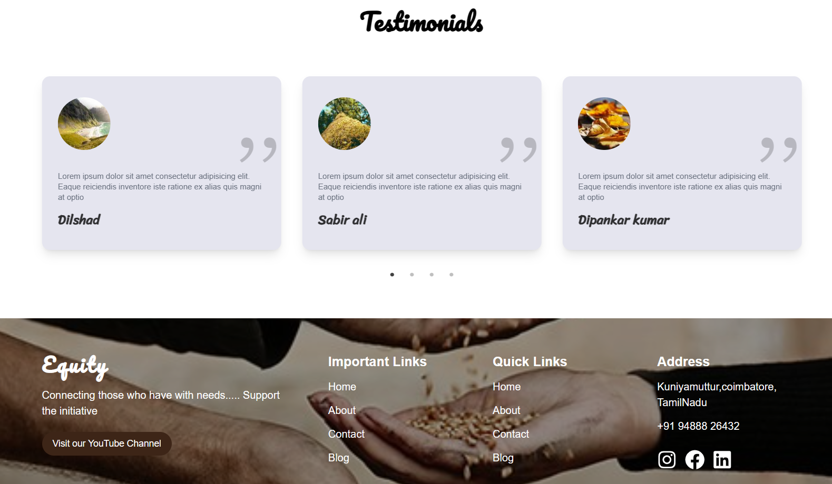

**Donate and Request:**

On our Donate page, users can contribute to our humanitarian efforts by providing essential information about the resources they wish to donate. To ensure privacy and security, we leverage blockchain technology to protect sensitive donor information such as their name, address, phone number, and email. Blockchain enhances the privacy and security of donor information:

**1. Donate Resource Form:**

Users interact with a Donate Resource form that is secured on the blockchain. The blockchain ensures the integrity and immutability of the form, preventing unauthorized modifications or tampering with the data. Donor information provided on the form remains encrypted and accessible only to authorized parties, ensuring confidentiality.

**2. Decentralized Data Storage:**

Donor information is stored in a decentralized manner across multiple nodes within the blockchain network. This decentralized storage architecture enhances security by eliminating single points of failure and reducing the risk of data breaches. Each donor's information is cryptographically secured and can only be accessed using private keys, ensuring privacy and confidentiality.

**3. Smart Contracts for Privacy Protection:**

Smart contracts are employed to handle donor interactions and transactions securely. Privacy-preserving smart contract techniques, such as zero-knowledge proofs or ring signatures, are utilized to protect donor anonymity. Donor transactions and interactions are pseudonymized, ensuring that sensitive information remains confidential while still allowing for transparency and accountability in resource distribution.

**4. Anonymous Donation Option:**

For donors who prefer to remain anonymous, we offer an option to donate without providing personal information. Users can choose to contribute resources without disclosing their identity, ensuring their privacy and anonymity.

**4. Transparency and Trust:**

While donor information is kept confidential, we maintain transparency regarding the allocation and distribution of donated resources. Donors receive confirmation of their contribution and updates on how their donations are being utilized to support our humanitarian initiatives. Our commitment to transparency and accountability fosters trust among donors and reinforces our dedication to ethical practices.

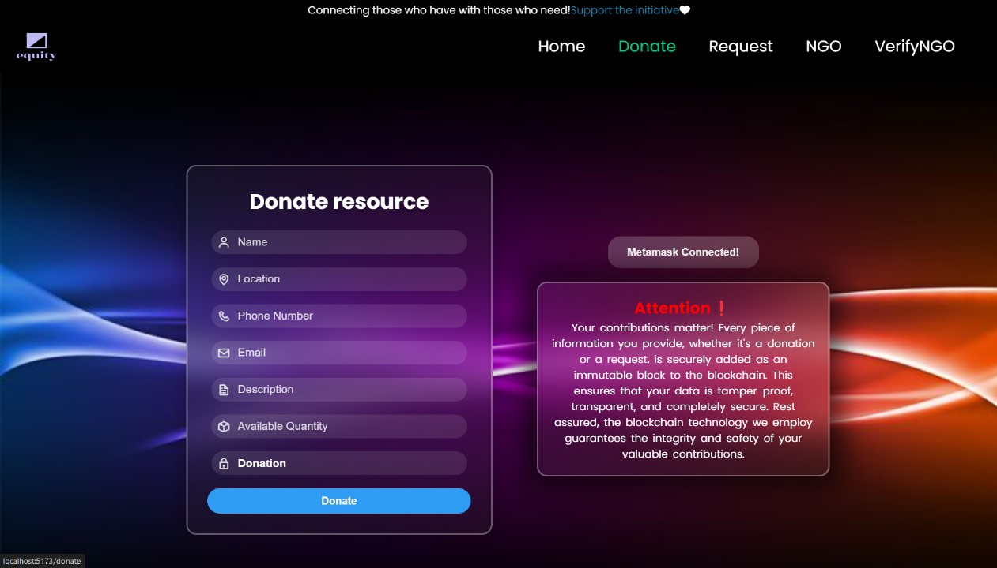

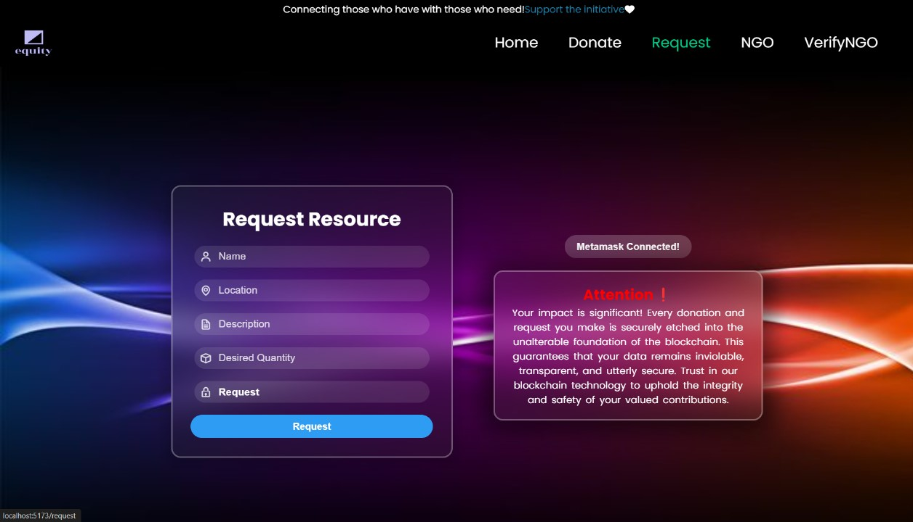

**NGO Login**

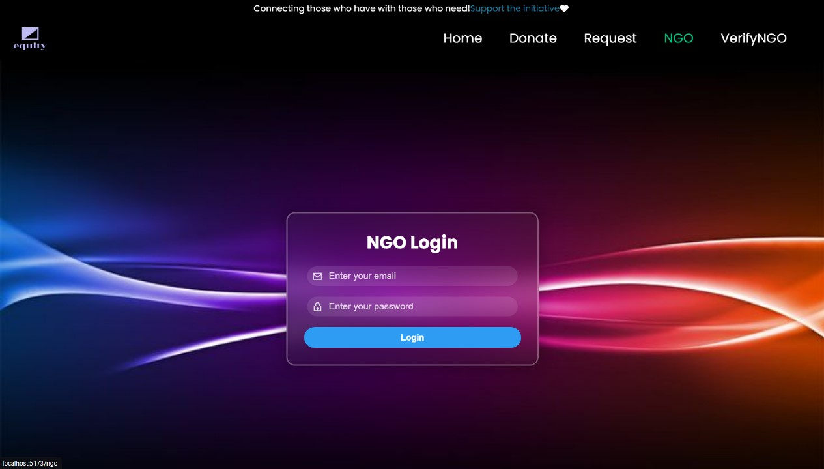

**NGOVerify:**

To ensure the credibility and trustworthiness of NGOs participating in our humanitarian exchange platform, we have implemented a rigorous verification process. Here's how the verification process works and why it's crucial:

**1. Document Submission:**

NGOs are required to submit relevant documentation and information to our platform for verification. This documentation typically includes registration certificates, mission statements, proof of legal status, and any other pertinent documents that establish the legitimacy of the organization.

**2. Manual Verification:**

Our dedicated team meticulously reviews and verifies the submitted documents to ensure compliance with our platform's standards and criteria. This manual verification process involves cross-referencing the provided information with authoritative sources and conducting thorough checks to confirm the authenticity of the NGO.

**3. Access Provision:**

Once an NGO successfully passes the verification process, we grant them login access to our platform. This access enables them to manage their profiles, submit resource requests, and facilitate the distribution of donated resources to requesters in need.

**4. Importance of Verification:**

Verifying NGOs is essential for several reasons:

* **Ensuring Trust:** By verifying NGOs, we instill trust and confidence among users, donors, and stakeholders in the integrity of our platform.
* **Protecting Donor and User Privacy:** Verified NGOs are entrusted with sensitive donor information and donated resources. Therefore, it's critical to ensure that only legitimate and trustworthy organizations have access to this information.
* **Enhancing Accountability:** Verified NGOs play a crucial role in the resource distribution process. By holding them accountable through the verification process, we maintain transparency and accountability in our operations.

**5. Facilitating Resource Exchange:**

Verified NGOs serve as intermediaries between donors and requesters, facilitating the exchange of donated resources. They are responsible for ensuring that donated resources reach the intended recipients in a timely and efficient manner while upholding ethical and responsible practices.

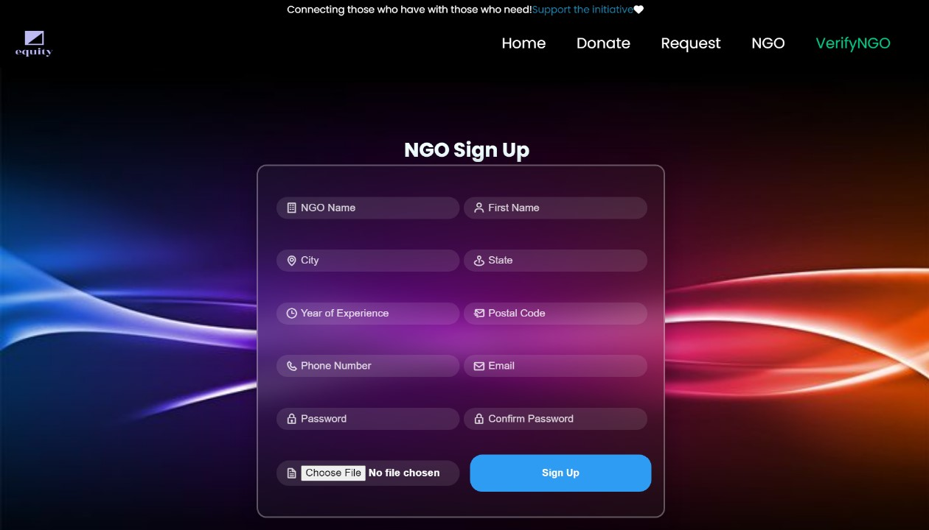

**DonateTransactions:**

To store donor information securely on the blockchain, we can utilize a smart contract called DonateTransactions. This smart contract will handle the storage and management of donor data, ensuring confidentiality, integrity, and immutability. we can design the DonateTransactions smart contract:

///solidity

// SPDX-License-Identifier: MIT

pragma solidity ^0.8.0;

contract DonateTransactions {

// Struct to store donor information

struct Donor {

string name;

string location;

uint256 resourceAvailability;

address addedBy; // Address of the account that added the donor information

}

// Mapping to store donor information by donor address

mapping(address => Donor) public donors;

// Event to log donor information added to the contract

event DonorAdded(address indexed donorAddress, string name, string location, uint256 resourceAvailability, address indexed addedBy);

// Modifier to restrict access to only authorized accounts

modifier onlyAuthorized {

// Implement access control logic here, e.g., require(msg.sender == adminAddress);

_;

}

// Function to add donor information to the contract

function addDonor(string memory _name, string memory _location, uint256 _resourceAvailability) public {

// Ensure that the donor information is not empty

require(bytes(_name).length > 0, "Name cannot be empty");

require(bytes(_location).length > 0, "Location cannot be empty");

// Add donor information to the mapping

donors[msg.sender] = Donor(_name, _location, _resourceAvailability, msg.sender);

// Emit an event to log the addition of donor information

emit DonorAdded(msg.sender, _name, _location, _resourceAvailability, msg.sender);

}

// Function to get donor information by donor address

function getDonor(address _donorAddress) public view returns (string memory, string memory, uint256) {

// Retrieve and return donor information

return (donors[_donorAddress].name, donors[_donorAddress].location, donors[_donorAddress].resourceAvailability);

}

}

**Explanation of the smart contract:**

**1. Donor Struct:**

Defines a struct `Donor` to store donor information, including name, location, resource availability, and the address of the account that added the donor information.

**2. Donors Mapping:**

Maps donor addresses to their corresponding `Donor` struct, allowing efficient retrieval of donor information.

**3. DonorAdded Event:**

Defines an event `DonorAdded` to log the addition of donor information to the contract.

**4. addDonor Function:**

Allows authorized accounts to add donor information to the contract. It requires non-empty name and location parameters and stores the information in the `donors` mapping.

**5. getDonor Function:**

Allows anyone to retrieve donor information by donor address. It returns the name, location, and resource availability of the donor.

**6. onlyAuthorized Modifier:**

Placeholder modifier to restrict access to certain functions to authorized accounts. You can implement access control logic as per your requirements.

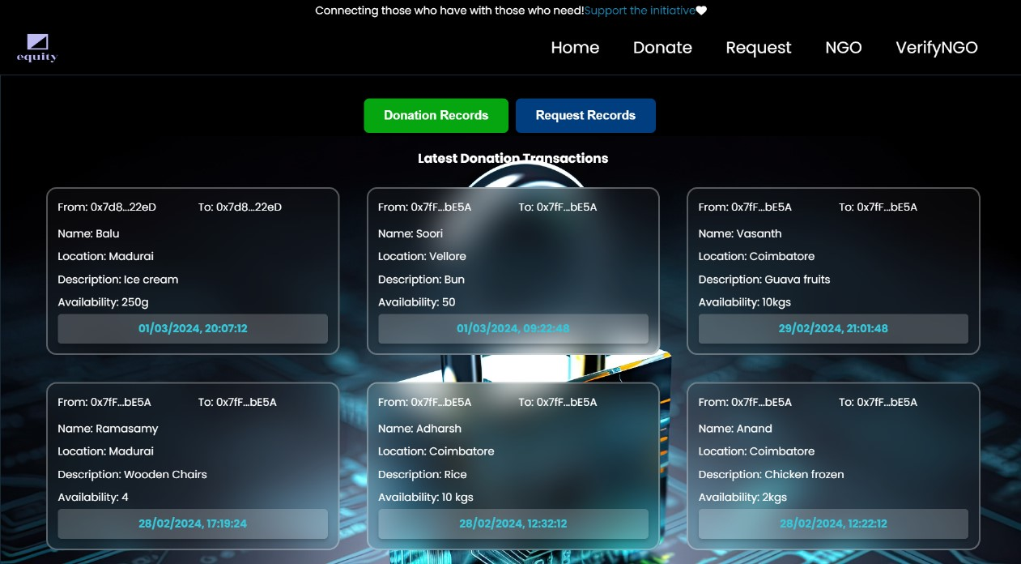

**RequestTransaction:**

To securely store request information from NGOs on the blockchain, we can implement a smart contract called RequestTransaction. This smart contract will handle the storage and management of request data, ensuring confidentiality, integrity, and immutability. we can design the RequestTransaction smart contract:

**//**solidity

// SPDX-License-Identifier: MIT

pragma solidity ^0.8.0;

contract RequestTransaction {

// Struct to store request information

struct Request {

string name;

string location;

uint256 resourceReceived;

address addedBy; // Address of the account that added the request information

}

// Mapping to store request information by request ID

mapping(uint256 => Request) public requests;

uint256 public requestId = 0;

// Event to log request information added to the contract

event RequestAdded(uint256 indexed requestId, string name, string location, uint256 resourceReceived, address indexed addedBy);

// Modifier to restrict access to only authorized accounts

modifier onlyAuthorized {

// Implement access control logic here, e.g., require(msg.sender == adminAddress);

_;

}

// Function to add request information to the contract

function addRequest(string memory _name, string memory _location, uint256 _resourceReceived) public {

// Ensure that the request information is not empty

require(bytes(_name).length > 0, "Name cannot be empty");

require(bytes(_location).length > 0, "Location cannot be empty");

// Increment the request ID

requestId++;

// Add request information to the mapping

requests[requestId] = Request(_name, _location, _resourceReceived, msg.sender);

// Emit an event to log the addition of request information

emit RequestAdded(requestId, _name, _location, _resourceReceived, msg.sender);

}

// Function to get request information by request ID

function getRequest(uint256 _requestId) public view returns (string memory, string memory, uint256) {

// Retrieve and return request information

return (requests[_requestId].name, requests[_requestId].location, requests[_requestId].resourceReceived);

}

**Explanation of the smart contract:**

**1. Request Struct:**

Defines a struct `Request` to store request information, including name, location, resource received, and the address of the account that added the request information.

**2. requests Mapping:**

Maps request IDs to their corresponding `Request` struct, allowing efficient retrieval of request information.

**3. RequestAdded Event:**

Defines an event `RequestAdded` to log the addition of request information to the contract.

**4. addRequest Function:**

Allows authorized accounts to add request information to the contract. It requires non-empty name and location parameters, increments the request ID, and stores the information in the `requests` mapping.

**5. getRequest Function:**

Allows anyone to retrieve request information by request ID. It returns the name, location, and resource received of the request.

**6. onlyAuthorized Modifier:**

Placeholder modifier to restrict access to certain functions to authorized accounts. You can implement access control logic as per your requirements.

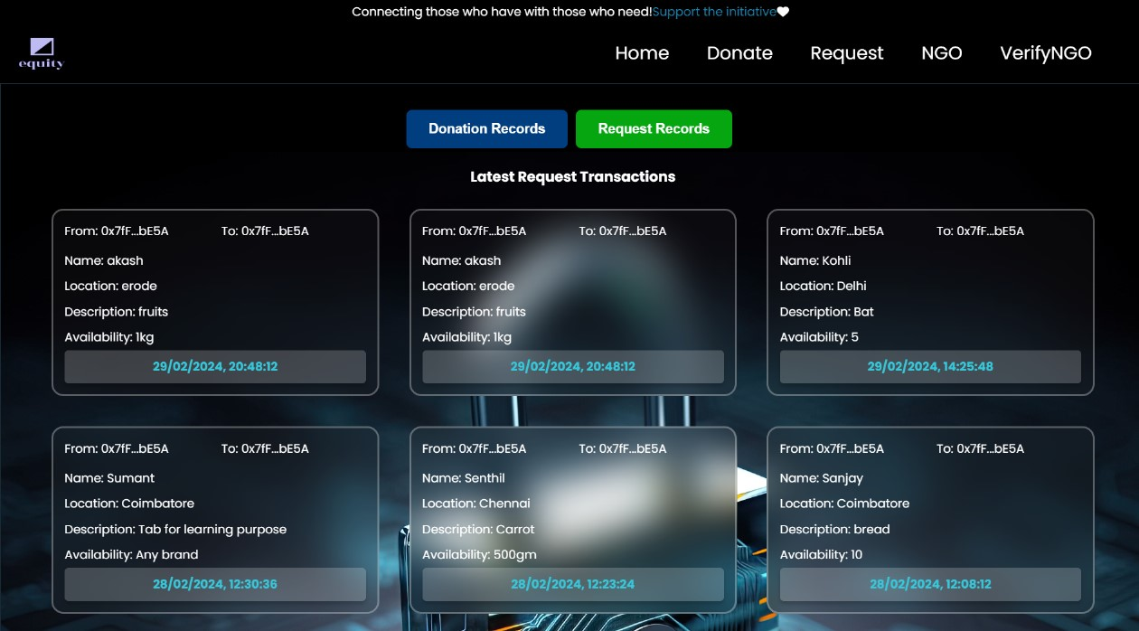

**CHAPTER 7**

**CONCLUSION:**

In conclusion, this project epitomizes the fusion of technology and social responsibility, offering a beacon of hope in addressing pressing societal challenges. By leveraging blockchain, and robust cybersecurity measures, the platform facilitates efficient and transparent surplus resource distribution, striving to reduce inequalities and foster a more compassionate society. Through collaboration with NGOs and stakeholders, it champions collective action towards a more equitable future. This initiative underscores the transformative potential of technology in driving positive social change, epitomizing the ethos of innovation for the greater good.

**FUTURE WORK:**

This project involve scalability enhancements to accommodate growing user bases and resource volumes, potentially integrating decentralized finance (DeFi) mechanisms for transparent fund management. Expansion into diverse sectors like food, healthcare, and education broadens its societal impact. Integration with emerging technologies such as IoT and enhances resource tracking and optimization. Collaboration with governments and international organizations could lead to broader adoption and policy support. Evolution towards a DAO (Decentralized Autonomous Organization) model empowers community governance. Continuous innovation in consensus algorithms ensures efficiency and sustainability. Overall, the project holds promise for reshaping resource distribution paradigms and fostering inclusive, sustainable development globally.

**REFERENCES:**

1. De Filippi, P., & Wright, A. (2016). "Smart Contracts: Building Blocks for Digital Markets." Harvard University Press. DOI: 10.4159/9780674977660

2. eToro. (2018). "The State of Blockchain: The Future of Blockchain and Distributed Ledger Technology." eToro. DOI: 10.2139/ssrn.329469

3. Hadi Saleh; Sergey Avdoshin; Azamat Dzhonov. (2-14 November 2019). “Platform for Tracking Donations of Charitable Foundations Based on Blockchain Technology”. DOI: 10.1109/APSSE47353.2019.00031

4. Muhammad Irfan Khalid, Ibtisam Ehsan. (27 January 2023) "A Comprehensive Survey on Blockchain-Based Decentralized Storage Networks" DOI:10.1109/ACCESS.2023.3240237

5. Kumar Satyam, Ayush Sharma.(14-16 September 2023) "Implementing Blockchain Based Security in EHR Using Ganache" DOI: 10.1109/IC3I59117.2023.10397841

6. Christina Varghese. (27-30 January 2021) "SeVa: A Food Donation App for Smart Living" DOI: 10.1109/CCWC51732.2021.9375945

7. Tillemann, T., & Luo, A. (2017). "Blockchain for Social Impact: Moving Beyond the Hype." The World Bank. DOI: 10.1596/978-1-4648-1109-1

# 